**CS342 – Operating Systems Lab**

**Lab 8**

**Bankers Algorithm**

Tarusi Mittal 1901CS65

**Question 1:** Write a Program to Implement Bankers algorithm.

1. Given allocated, max and available resources (should be taken as input from user) for n number of process The code should print if there is any safe sequence available.
2. For the above problem, print all the different safe sequences possible.

**Answer:**

**What is Bankers Algorithm?**

The banker’s algorithm is a resource allocation and deadlock avoidance algorithm that tests for safety by simulating the allocation for predetermined maximum possible amounts of all resources, then makes an “s-state” check to test for possible activities, before deciding whether allocation should be allowed to continue.

**Compilation:**

g++ -P1.cpp -o P1

**Syntax:**

./P1

Number of processes

Number of resources

Available resources array

Allocated resources

**Sample Output:**

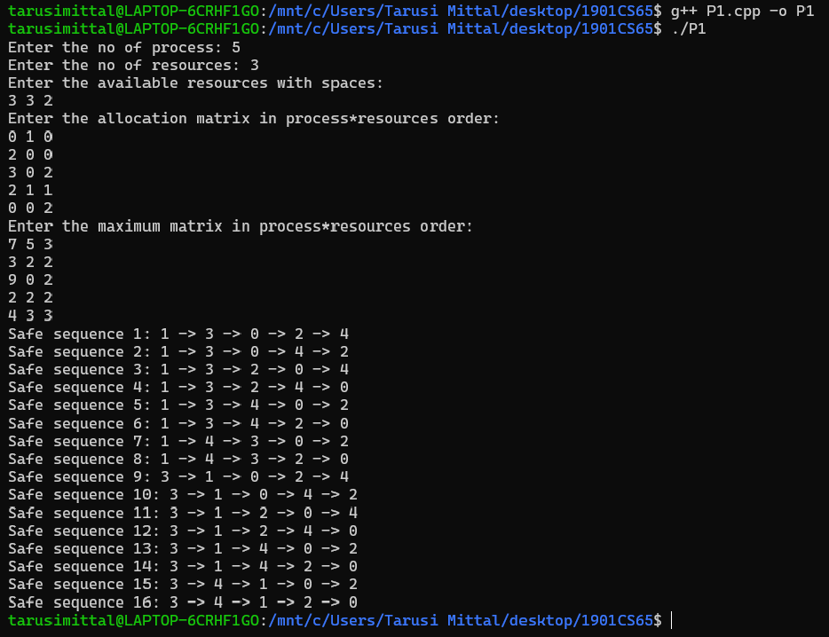

Safe sequence 1: 1 -> 3 -> 0 -> 2 -> 4

Safe sequence 2: 1 -> 3 -> 0 -> 4 -> 2

Safe sequence 3: 1 -> 3 -> 2 -> 0 -> 4

Safe sequence 4: 1 -> 3 -> 2 -> 4 -> 0

Safe sequence 5: 1 -> 3 -> 4 -> 0 -> 2

Safe sequence 6: 1 -> 3 -> 4 -> 2 -> 0

Safe sequence 7: 1 -> 4 -> 3 -> 0 -> 2

Safe sequence 8: 1 -> 4 -> 3 -> 2 -> 0

Safe sequence 9: 3 -> 1 -> 0 -> 2 -> 4

Safe sequence 10: 3 -> 1 -> 0 -> 4 -> 2

Safe sequence 11: 3 -> 1 -> 2 -> 0 -> 4

Safe sequence 12: 3 -> 1 -> 2 -> 4 -> 0

Safe sequence 13: 3 -> 1 -> 4 -> 0 -> 2

Safe sequence 14: 3 -> 1 -> 4 -> 2 -> 0

Safe sequence 15: 3 -> 4 -> 1 -> 0 -> 2

Safe sequence 16: 3 -> 4 -> 1 -> 2 -> 0

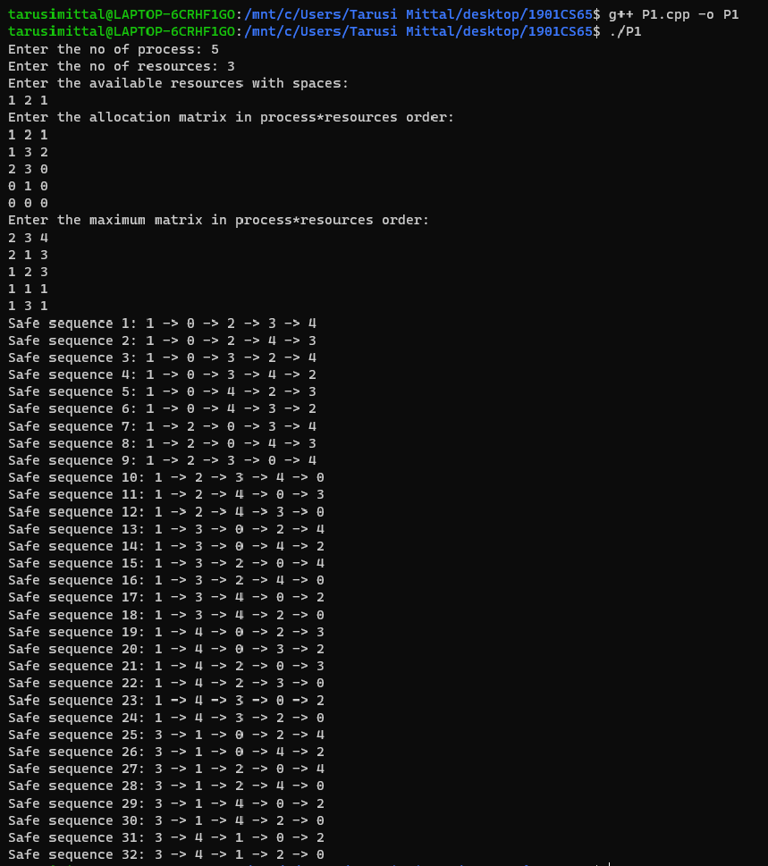

Safe sequence 1: 1 -> 0 -> 2 -> 3 -> 4

Safe sequence 2: 1 -> 0 -> 2 -> 4 -> 3

Safe sequence 3: 1 -> 0 -> 3 -> 2 -> 4

Safe sequence 4: 1 -> 0 -> 3 -> 4 -> 2

Safe sequence 5: 1 -> 0 -> 4 -> 2 -> 3

Safe sequence 6: 1 -> 0 -> 4 -> 3 -> 2

Safe sequence 7: 1 -> 2 -> 0 -> 3 -> 4

Safe sequence 8: 1 -> 2 -> 0 -> 4 -> 3

Safe sequence 9: 1 -> 2 -> 3 -> 0 -> 4

Safe sequence 10: 1 -> 2 -> 3 -> 4 -> 0

Safe sequence 11: 1 -> 2 -> 4 -> 0 -> 3

Safe sequence 12: 1 -> 2 -> 4 -> 3 -> 0

Safe sequence 13: 1 -> 3 -> 0 -> 2 -> 4

Safe sequence 14: 1 -> 3 -> 0 -> 4 -> 2

Safe sequence 15: 1 -> 3 -> 2 -> 0 -> 4

Safe sequence 16: 1 -> 3 -> 2 -> 4 -> 0

Safe sequence 17: 1 -> 3 -> 4 -> 0 -> 2

Safe sequence 18: 1 -> 3 -> 4 -> 2 -> 0

Safe sequence 19: 1 -> 4 -> 0 -> 2 -> 3

Safe sequence 20: 1 -> 4 -> 0 -> 3 -> 2

Safe sequence 21: 1 -> 4 -> 2 -> 0 -> 3

Safe sequence 22: 1 -> 4 -> 2 -> 3 -> 0

Safe sequence 23: 1 -> 4 -> 3 -> 0 -> 2

Safe sequence 24: 1 -> 4 -> 3 -> 2 -> 0

Safe sequence 25: 3 -> 1 -> 0 -> 2 -> 4

Safe sequence 26: 3 -> 1 -> 0 -> 4 -> 2

Safe sequence 27: 3 -> 1 -> 2 -> 0 -> 4

Safe sequence 28: 3 -> 1 -> 2 -> 4 -> 0

Safe sequence 29: 3 -> 1 -> 4 -> 0 -> 2

Safe sequence 30: 3 -> 1 -> 4 -> 2 -> 0

Safe sequence 31: 3 -> 4 -> 1 -> 0 -> 2

Safe sequence 32: 3 -> 4 -> 1 -> 2 -> 0

END